Contents

**Create the ASP.NET MVC core Web APP project.** 2

# **Create the ASP.NET MVC core Web APP project.**

1. Open Visual Studio 2022 in Admin mode.
2. Select Visual Studio , then click “Create a new project” from Right hand.
3. Select ASP.NET Core Web App (Model-View-Controller) and click Next button.

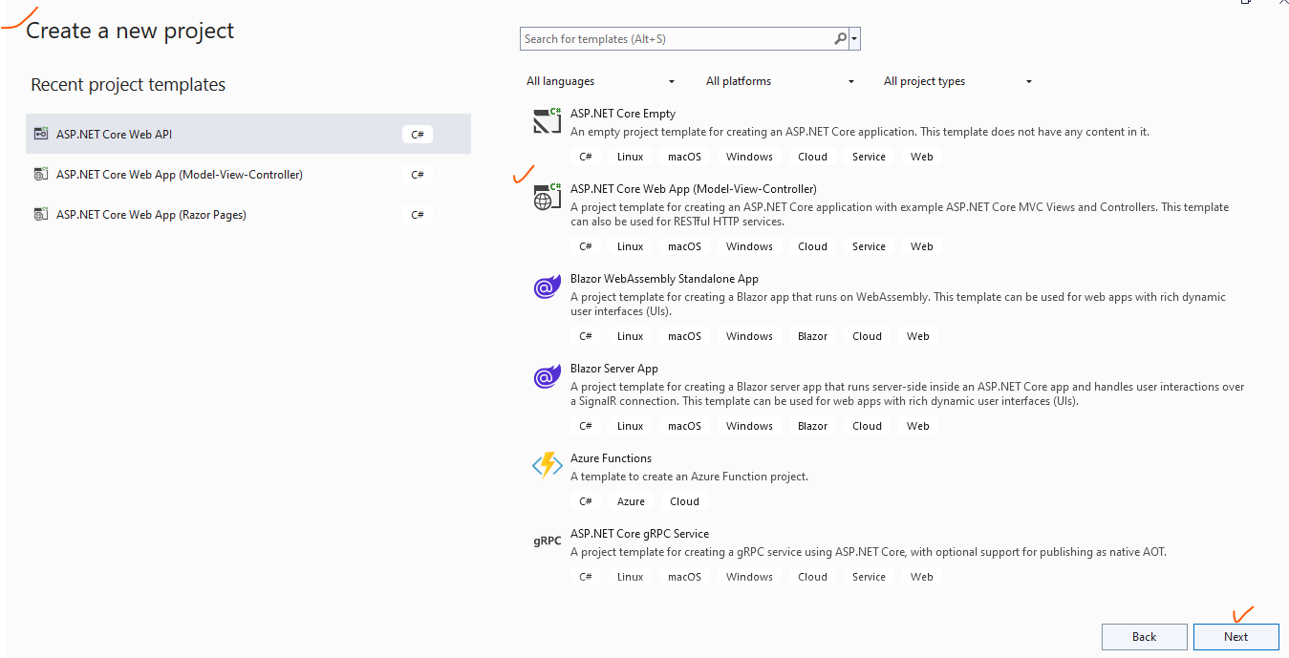

1. A screenshot of a computer

   Description automatically generatedProvide the Project path and Project and Solution name.
2. Additional setting, selecting the .NET Framework.

***Please note*** *that both .NET application and Azure Application Service must be same .NET framework, otherwise publishing will fail. In this demo selected the .NET Framework 6.0.*

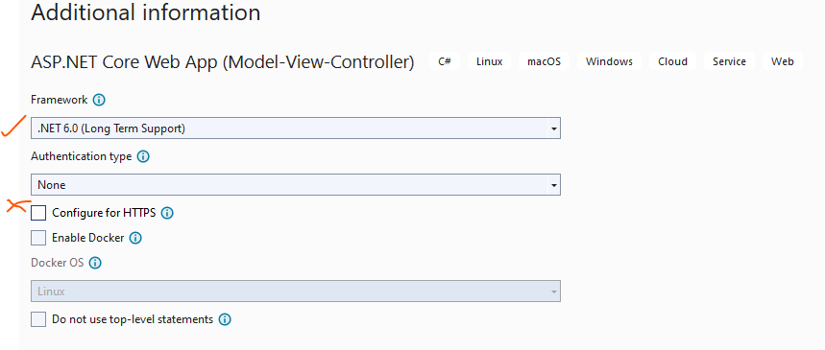

1. Then click “Create” button. VS will create the MVC application.

Below is the default folders and Solution structure.

Please note that. Up to this level only App has been created.

Code not configured to any Source Code. We have options to add the source code to either GitHub or Azure DevOps.